Essay #1

Due Sunday September 23.
The last day for a consultation is Thursday, September 21.

Topic: What is a function?

Some ideas you need to consider:

- Write the definition of a function in your own words.
- What does a function look like? Is it always a graph?
- What are the attributes of a function?
- What are some tips for discovering if a relationship is a function or not?
- What is (and is not) a function from the viewpoint of a variety of disciplines
(anthropology, English, physics)? How are these different from but related to the functions we looked at in class?
- Include multiple representations of functions (e.g. graphic, symbolic, words, mappings, etc.) and discuss which attributes are best shown in each representation.
- Include a bibliography if needed; it does not count in your word count, though.

Audience: Ms. Leigh, who has suffered slight amnesia, needs to be reminded of mathematical basics. She needs to be able to read the details and supporting evidence for your statements in order to feel that what you’ve written is both relevant and accurate.

Assignment format:

This will be a 700 word descriptive essay that is typed (12 point) and double spaced with margins not larger than 1 inch per side. The Proof of Attendance form from The Writing Center must be attached at the back of the essay along with a copy of the rubrics for me to use in grading your essay.

Grading Rubric: next page, attach to essay with PoA

10% your grade

Rubrics Sheet for: Essay #1

Name:__________________

Topic Development and Task Responsiveness (5 points):
Fulfills the purpose of the essay; addresses the considerations
Includes all relevant facts; is free from factual errors
Develops the context of the topic in mathematics/other disciplines
Has a well-defined and well-supported thesis
Demonstrates mastery of the topic

Critical Thinking (5 points):
Clear reasoning and idea development, treats the subject as complex
Good references cited and rewritten in the student’s voice
Demonstrates a high level of reflection and synthesis
Determines relevant patterns, inferences, and connections
Shows logical inquiry and reasoning

Conventions, Mechanics, and Readability (5 points):
Good grammar and proper use of math terminology throughout
Introductory paragraph is well organized and engaging
References are used appropriately and structure is evident
Good transitions between thoughts and paragraphs
Summary is concise and provides closure

______ Receipt from Writing Center (3 points)
______ Received by deadline (2 points off each day late)

Essay #2

Due Sunday, October 28.
Last day for consultation is Thursday, October 26.

Topic: Devise a visual, verbal, and algebraic way of
connecting the following three concepts.

- The Euclidean distance formula
- The Standard Equation of a Circle centered at (h, k)
- The Pythagorean Theorem

Some ideas you need to consider:

- Think of at least 2 related mathematical or real life topics that can be extended from these three topics.
- Historically, what came first?
- Are there graphical and symbolic connections you can illustrate?
- How were these topics introduced and taught to you? Can you think of a more interesting or compelling approach? What did you learn from this topic?

Audience: Ms. Leigh, who has suffered slight amnesia, needs to be reminded of mathematical basics. She needs to be able to read the details and supporting evidence for your statements in order to feel that what you’ve written is both relevant and accurate.

Assignment format:

This will be a 700 word descriptive essay that is typed (12 point) and double spaced with margins not larger than 1 inch per side. The Proof of Attendance form from The Writing Center must be attached at the back of the essay along with the Rubrics Sheet for me to use in grading your essay.

Grading Rubric: next page, attach to essay with PoA

10% of your grade

Rubrics Sheet for_Essay #2

Name:__________________

Topic Development and Task Responsiveness (5 points):
Uses many modes of showing connections; addresses considerations
Includes all relevant facts; is free from factual errors
Develops the context of the topic fully
Has a well-defined and well-supported thesis about the connections
Demonstrates mastery of the connections and history

Critical Thinking (5 points):
Clear reasoning and idea development; clear and precise
Good references cited and rewritten in the student’s voice
Demonstrates a high level of reflection and synthesis
Determines relevant patterns, inferences, and connections
Shows logical inquiry and reasoning

Conventions, Mechanics, and Readability (5 points):
Good grammar and proper use of math terminology throughout
Introductory paragraph is well organized and engaging
References are used appropriately; illustrations are attributed
Good transitions between thoughts and paragraphs
Summary is concise and provides closure

______ Receipt from Writing Center (3 points)
______ Received by deadline (2 points off each day late)

Essay #3

Due Sunday, November 18.
Last day for consultation is Thursday, November16.

Topic: Eccentricity of a hyperbola

Investigate the geometric significance of the eccentricity of a hyperbola by completing the three steps that follow. Then write a report telling what you have done, what patterns you have observed, and what relationship you have found between the eccentricity and the shape of the hyperbola.

A. Use the definition of eccentricity*, e, to show, for the hyperbola

that e = .

*e = c/a where c is the distance from the center to a focus point.

I want to see how you go from the definition ( e = c/a) to the formula with the square root in neat precisely written steps…almost a proof. How are a, b, c, and eccentricity related? How does the eccentricity show up in the graph or predict the graph?

B. Compute and report the eccentricity for each of the following five hyperbolas with a calculator:

Discuss the utility of these choices for illustration. Why NOT just any 5 hyperbolas? How does it help you understand eccentricity to use these specific ones? What is the relationship between eccentricity and shape?

Why is this a math experiment? What do you notice about the design of the steps you are following that makes this a well-designed experiment?

Essay #3 continued

C. Use graphing software to show Quadrant 1 for each of these 5 on the same set of axes. Insert this picture in your essay with a cogent caption.

Audience: Ms. Leigh, who has suffered slight amnesia, needs to be reminded of mathematical basics. She needs to be able to read the details and supporting evidence for your statements in order to feel that what you’ve written is both relevant and accurate.

Assignment format:

This will be a 700 word descriptive essay that is typed (12 point) and double spaced with margins not larger than 1 inch per side. The Proof of Attendance form from The Writing Center must be attached at the back of the essay along with the Rubrics Sheet that I will use in grading your essay

Grading Rubric: next sheet; attach to essay along with PoA

10% of your grade

Rubrics Sheet for Essay #3

Name:_________________

Topic Development and Task Responsiveness (5 points):
Full and balanced consideration of each part of the problem: A - C
Includes all relevant facts; is free from factual errors
Good analysis of the experimental structure and what it provides
Has a well-defined and well-supported thesis
Demonstrates mastery of the topic visually and in the text

Critical Thinking (5 points):
Clear reasoning and idea development, treats the subject as complex
Good use of technology and visualization techniques
Demonstrates a high level of reflection and synthesis
Determines relevant patterns, inferences, and connections
Shows logical inquiry and reasoning

Conventions, Mechanics, and Readability (5 points):
Good grammar and proper use of math terminology throughout
Introductory paragraph is well organized and engaging
References are used appropriately and structure is evident
Good transitions between thoughts and paragraphs
Summary is concise and provides closure

______ Receipt from Writing Center (3 points)
______ Received by deadline (2 points off each day late)

Term paper:

Due Sunday Dec.09 midnight-ish.

There will be a group session in The Writing Center during class time on Thursday, November 30.
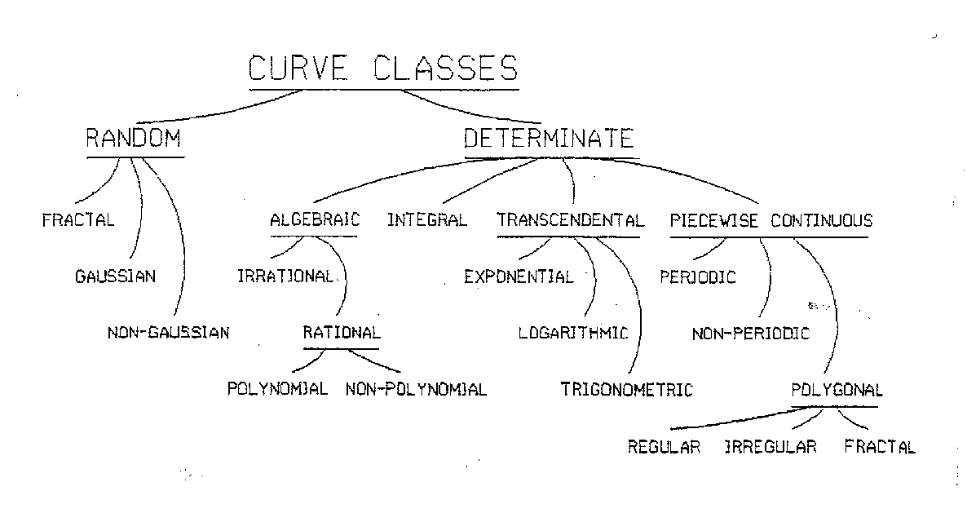
Topic: Discuss the following outline of curves and how the topics of our class fit into it.
Some ideas you need to consider:

- What is a curve? Are all functions curves? Are all curves functions?
- What is the organizing principle of this outline? How did we organize our information about functions? Compare and contrast these organizing principles.
- What do the words “algebraic”, “determinate”, and “transcendental” mean?
Did we study any of these? How do you know?

Audience: Ms. Leigh, who is fully recovered, wants to see what you learned and how you’re analyzing math topics now that we’re through the course. Impress me!

Assignment format:
This will be a 1500 word term paper. It will be typed (12 point) and double spaced with margins not wider than 1 inch. The bibliography is not counted in the paper length.

Grading Rubric: On next page. Attach it to your essay.

This paper is 15% of your grade in this class.

Rubrics Sheet for Term Paper

Name:____________________

Topic Development and Task Responsiveness (5 points):
Fulfills the purpose of the essay; gives the “Big Picture”
Includes all relevant facts; is free from factual errors
Develops the context of the topic in mathematics as a whole
Has a well-defined and well-supported thesis
Demonstrates mastery of the topic; full discussion of the considerations

Critical Thinking (5 points):
Clear reasoning and idea development, treats the subject as complex
Good references cited and rewritten in the student’s voice
Demonstrates a high level of synthesis in vocabulary and outline
Determines relevant connections to classwork
Shows logical inquiry and reasoning in meshing the classwork

Conventions, Mechanics, and Readability (5 points):
Good grammar and proper use of math terminology throughout
Introductory paragraph is well organized and engaging
References are used appropriately and structure is evident
Good transitions between thoughts and paragraphs
Summary is concise and provides closure

______ Attended group session (3 points)
______ Received by deadline (2 points off each day late)

